**Develop A Web Application Using Node-RED**

**TEAM ID :** PNT2022TMID53603

**PROJECT NAME :** IOT BASED SAFETY GADGET FOR CHILD SAFETY MONITORING AND NOTIFICATION.

**Steps Followed:**

**Openeda Node-RED project**

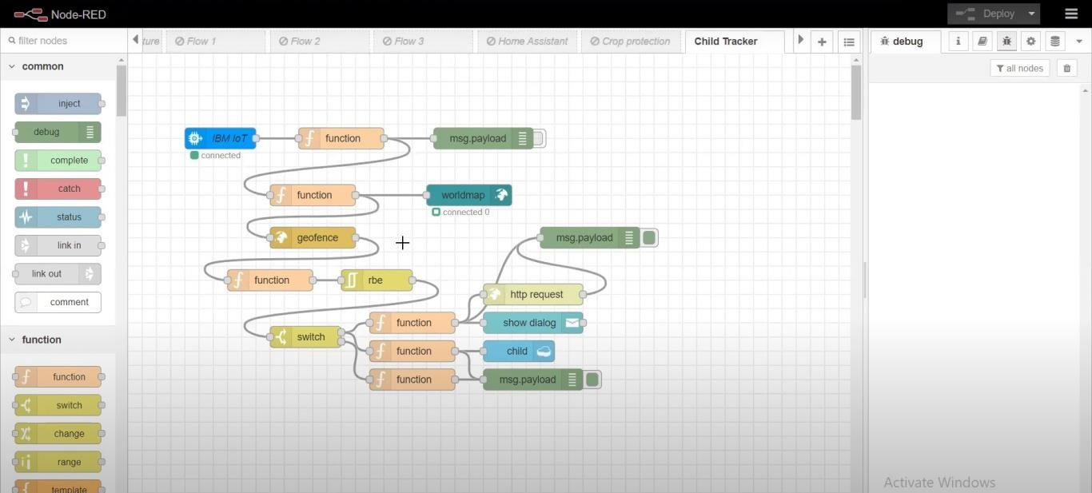

**Added code to get child location in python:**

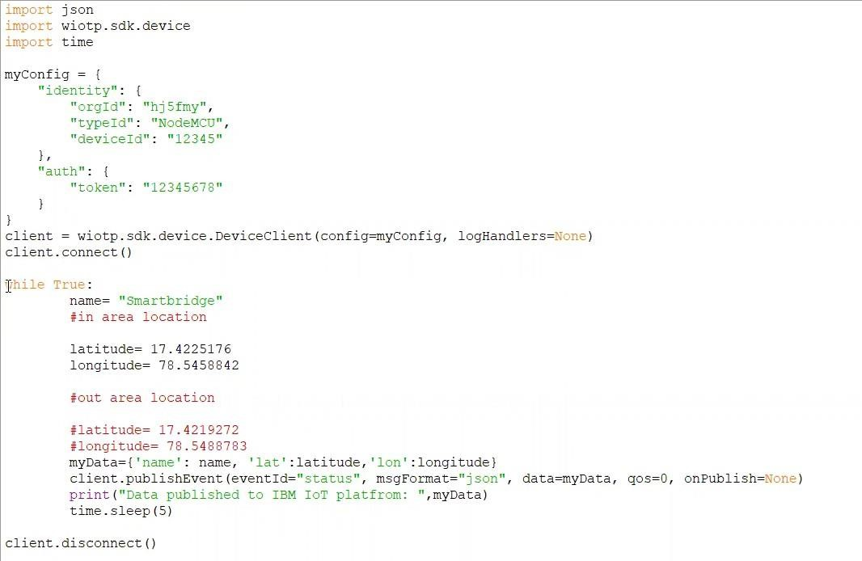

**Created the Geo-Fence:**

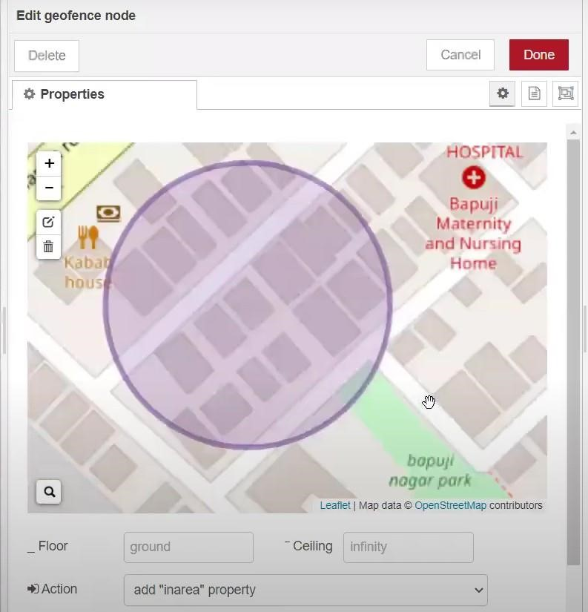

**Editing the HTTP Request URL :**

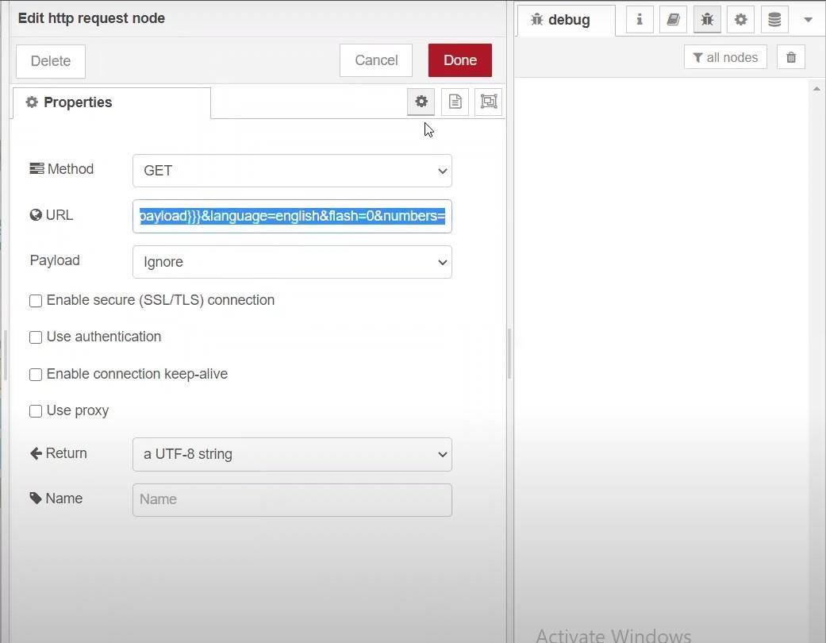

**Located the child :**

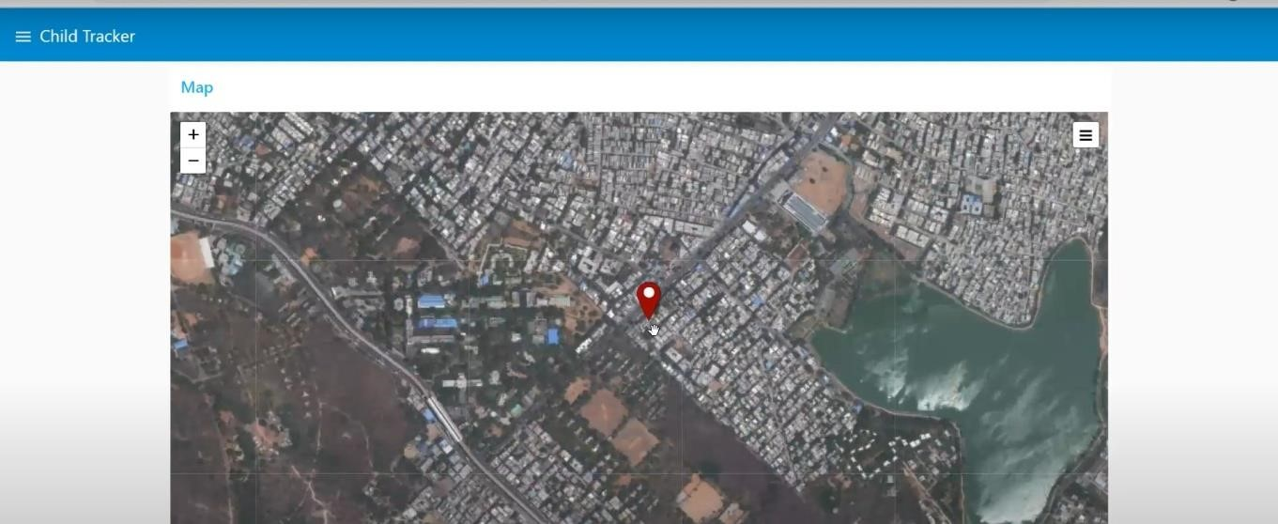

**Created the geo-fence node :**

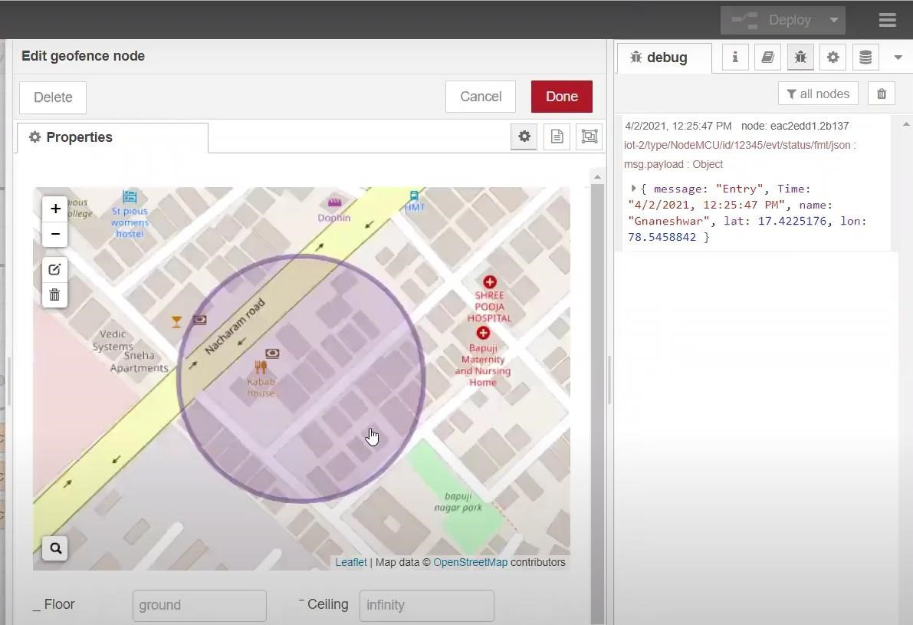

**Python script sending requests to IBM Cloud :**

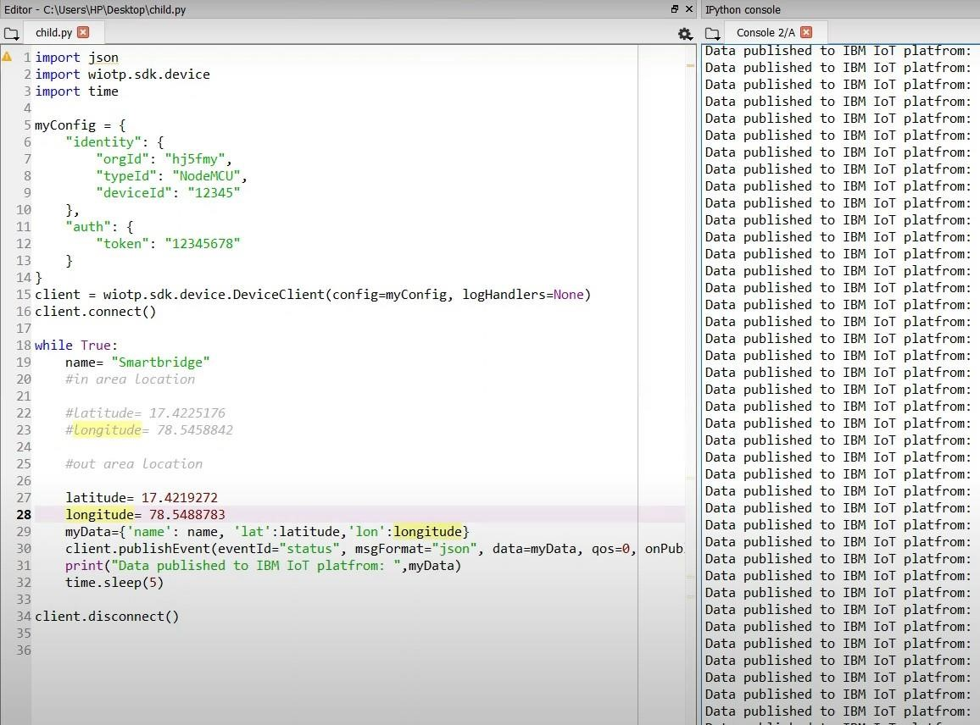

**After running the script the web UI shows “Person is not in the particular area”:**

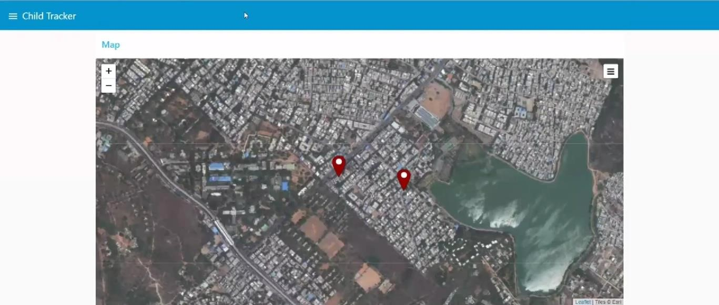

**Result :** **Successfully developed a web application using Node-RED**